**For more information, contact:**

Julie Caan, 920-912-3445

jcaan@bader-rutter.com

**Case IH Steiger® 620 Tractor Sets New Performance Records for Fluid-efficient Horsepower and Maximum Pull in Nebraska Test Results**



RACINE, Wis. (Feb. 9, 2017) —

New test results prove the Case IH Steiger 620 is the most fluid-efficient and highest drawbar horsepower tractor in the world.1

In recent tests at the University of Nebraska Tractor Test Laboratory (NTTL), the Steiger 620 tractor set new records for drawbar fuel efficiency, drawbar horsepower and maximum pull — outperforming all models ever tested.

“It’s one thing to generate a lot of horsepower,” said Mitch Kaiser, Case IH Steiger tractor marketing manager. “But it’s just as important to efficiently transfer that power throughout the tractor and, ultimately, to the ground and to the implement you’re pulling. That fluid efficiency — including diesel fuel and Diesel Exhaust Fluid (DEF) — translates directly to lower operating costs.”

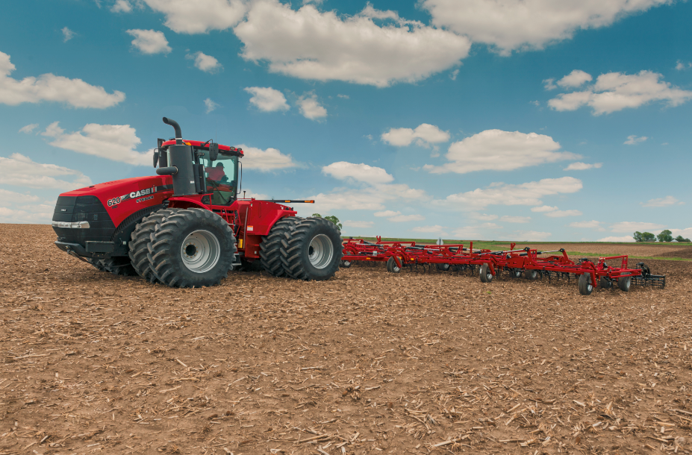

Caption: In newly released Nebraska Tractor Test Laboratory results, the Steiger® 620 tractor set new records for fluid-efficient drawbar horsepower and maximum pull.

Click [[HERE]](http://www.caseih.com/en_us/PressRoom/Pages/Media-Library.aspx) to download a hi-res file.

In addition to the Steiger 620 achieving the highest marks recorded for any tractor ever tested at NTTL, the Steiger 580 scored the second-highest drawbar fuel economy ever recorded* at 17.53 horsepower hours per gallon — 6.63 percent higher than the tested competition in its power class.2

The complete Steiger tractor lineup (370 to 620 horsepower) features best-in-class power, torque and fluid efficiency.

“Whether in the lab or in the field — where it really matters — our patented Selective Catalytic Reduction (SCR) emissions technology provides the most power and best fuel economy, even when pulling the heaviest loads,” Kaiser said. “Because our engines run cleaner and cooler and the power they generate transfers efficiently via the transmission and driveline, our customers reap the benefits of better fluid efficiency plus additional power dedicated to the drawbar.”

With Case IH engines, there’s no particulate filter to clean, no regeneration period and 600 operating hours between oil changes. Steiger engines are designed with maximum power while saving diesel and DEF. Average fluid operating cost is 2.2 percent less across Steiger tractors (370 to 620 horsepower) than comparable competitive models.3

“In today’s farming economy, it all comes back to increased performance with lower operating costs,” Kaiser said. He added that, on average, Steiger tractors cost up to $1,000 less to own and maintain than comparable John Deere® models.4

The NTTL is the officially designated tractor testing station for the United States and tests tractors according to the Organization for Economic Co-operation and Development (OECD) codes. Twenty-nine countries adhere to the OECD tractor test codes, with active test stations in 25 countries around the world.

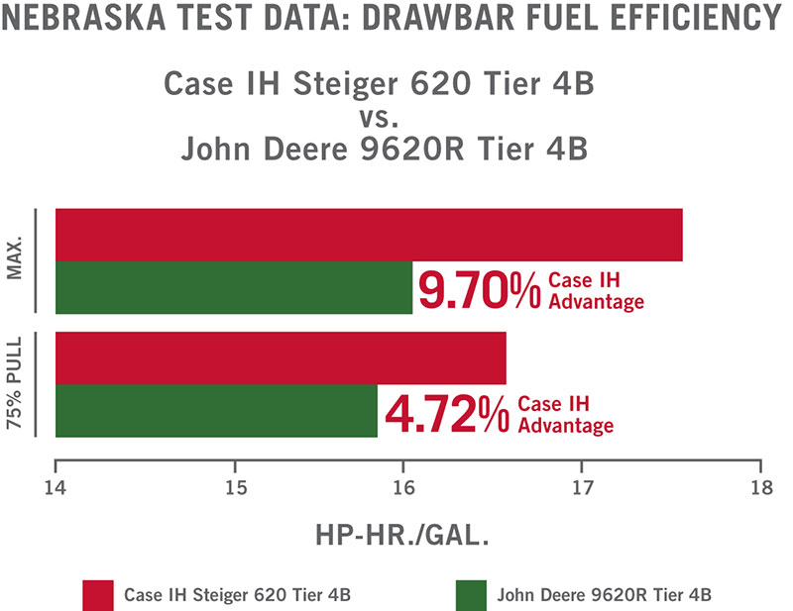

Caption: In recent independent tests, the Steiger® 620 tractor set a record for drawbar fuel efficiency — outperforming the tested competition in its power class and all models ever tested.

Click [[HERE]](http://www.caseih.com/en_us/PressRoom/Pages/Media-Library.aspx) to download a hi-res file.

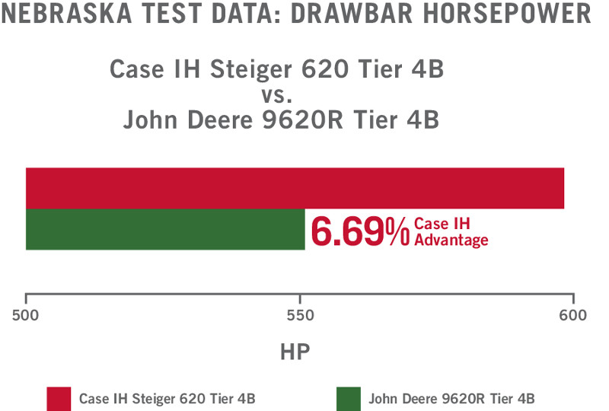

Caption: In recent independent tests, the Steiger® 620 set a record for drawbar horsepower — outperforming the tested competition in its power class and all models ever tested.

Click [[HERE]](http://www.caseih.com/en_us/PressRoom/Pages/Media-Library.aspx) to download a hi-res file.

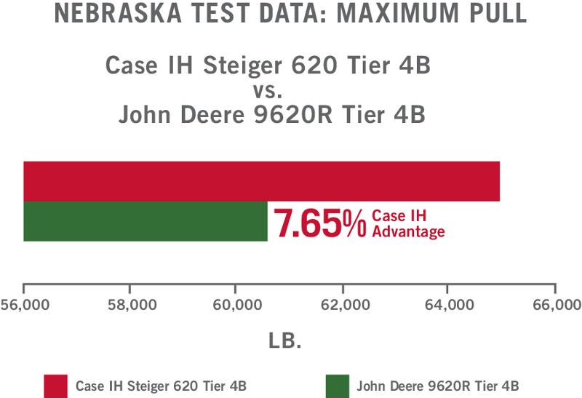

Caption: In recent independent tests, the Steiger® 620 tractor set a record for maximum pull — outperforming the tested competition in its power class and all models ever tested.

Click [[HERE]](http://www.caseih.com/en_us/PressRoom/Pages/Media-Library.aspx) to download a hi-res file.

“These results are a true testament to our Customer Driven Product Design process,” Kaiser said. “Through focus groups and continuous testing, our customers design and build our tractors right alongside Case IH engineers — ensuring this equipment is built for High-Efficiency Farming.”

In addition to feedback that helped deliver the best fluid efficiency, horsepower, drawbar pull and torque in the industry, Kaiser credits customers as the driving force behind other best-in-class features of Steiger tractors. These include up to a 20 percent faster and smoother shifting transmission, resulting in a 2 percent to 5 percent horsepower savings; tri-point oscillation for greater strength and durability when transferring power to the ground; a standard variable rate steering system for smoother operation; and standard, exclusive full-cab suspension for the best ride in the industry.

Visit the [Nebraska Tractor Test Laboratory’s website](http://tractortestlab.unl.edu/) for complete ratings and competitive results.

Visit [caseih.com](https://www.caseih.com/northamerica/en-us/innovations/efficient-power/nebraska-test-results) or your local Case IH dealer for more information and to test-drive a Steiger tractor.

*1Steiger 620 Tier 4B (Nebraska Test 2164, September/October 2016): maximum drawbar fuel efficiency at 17.63 hp-hr./gal. and 75% of pull maximum power at 16.61 hp-hr./gal.; compared with John Deere 9620R Tier 4B (Nebraska Test 2135, November 2015): maximum drawbar fuel efficiency at 16.07 hp-hr./gal. and 75% of pull maximum power at 15.86 hp-hr./gal. Steiger 620 Tier 4B (Nebraska Test 2164, September/October 2016): drawbar horsepower at 594.08 hp; compared with John Deere 9620R Tier 4B (Nebraska Test 2135, November 2015): drawbar horsepower at 556.83 hp. Steiger 620 Tier 4B (Nebraska Test 2164, September/October 2016): maximum pull at 65,077 lb.; compared with John Deere 9620R Tier 4B (Nebraska Test 2135, November 2015): maximum pull at 60,455 lb.*

*\*Models tested at 100% load at rated speed.*

*2Steiger 580 Tier 4B (Nebraska Test 2162, October 2016): maximum drawbar fuel efficiency at 17.53 hp-hr./gal. and 75% of pull maximum power at 16.44 hp-hr./gal.; compared with John Deere 9570R (Nebraska Test, 2133 November 2015): maximum drawbar fuel efficiency at 15.71 hp-hr./gal. and 75% of pull maximum power at 15.42 hp-hr./gal. Steiger 580 Tier 4B (Nebraska Test 2162, October 2016): drawbar horsepower at 495.25 hp; compared with John Deere 9570R (Nebraska Test, 2133 November 2015): drawbar horsepower at 450.82 hp.*

*3Total fluid operating cost for wheeled Steiger 370 – 620 (Nebraska Test 2092, September 2014 (370), Nebraska Test 2093, September/October 2014 (420), Nebraska Test 2094, September 2014 (470), Nebraska Test 2095, September/October 2014 (500), Nebraska Test 2096, September 2014 (540), Nebraska Test 2162, October 2016 (580), Nebraska Test 2164, September/October 2016 (580)) compared with John Deere 9370R – 9620R (Nebraska Test 2107, March/April 2015 (9370R), Nebraska Test 2108, April 2015 (9420R), Nebraska Test 2109, April 2015 (9470R), Nebraska Test 2111, April/May 2015 (9520R), Nebraska Test 2133, November 2015 (9570R), Nebraska Test 2135, November 2015 (9620R)). Results based on diesel consumption (gal./hr.) multiplied by diesel price ($/gal.) plus DEF consumption (gal./hr.) multiplied by DEF price ($/gal.).*

*42.1% lower total operating cost by weighted average ($0.0023/hp-hr.). Yearly costs assume usage of 685 hours and average of 75% power. Results from PTO dyno and drawbar tests combined (Nebraska Test 2092, September 2014 (370), Nebraska Test 2093, September/October 2014 (420), Nebraska Test 2094, September 2014 (470), Nebraska Test 2095, September/October 2014 (500), Nebraska Test 2096, September 2014 (540), Nebraska Test 2162, October 2016 (580), Nebraska Test 2164, September/October 2016 (580), Nebraska Test 2107, March/April 2015 (9370R), Nebraska Test 2108, April 2015 (9420R), Nebraska Test 2109, April 2015 (9470R), Nebraska Test 2111, April/May 2015 (9520R), Nebraska Test 2133, November 2015 (9570R), Nebraska Test 2135, November 2015 (9620R)).*

Case IH is a global leader in agricultural equipment, committed to collaborating with its customers to develop the most powerful, productive, reliable equipment — designed to meet today’s agricultural challenges. With headquarters in the United States, Case IH has a network of dealers and distributors that operates in over 160 countries. Case IH provides agricultural equipment systems, flexible financial service offerings and parts and service support for professional farmers and commercial operators through a dedicated network of professional dealers and distributors. Productivity-enhancing products include tractors; combines and harvesters; hay and forage equipment; tillage tools; planting and seeding systems; sprayers and applicators; site-specific farming tools; and utility vehicles. Case IH is a brand of CNH Industrial N.V. (NYSE: CNHI / MI: CNHI). Any trademarks referred to herein, in association with goods and/or services of companies other than CNH Industrial America LLC, are the property of those respective companies.

###